DSA – ARRAY

1. Introduction to Arrays

Array is a linear data structure where all elements are arranged sequentially. It is a collection of elements of same data type stored at contiguous memory locations.
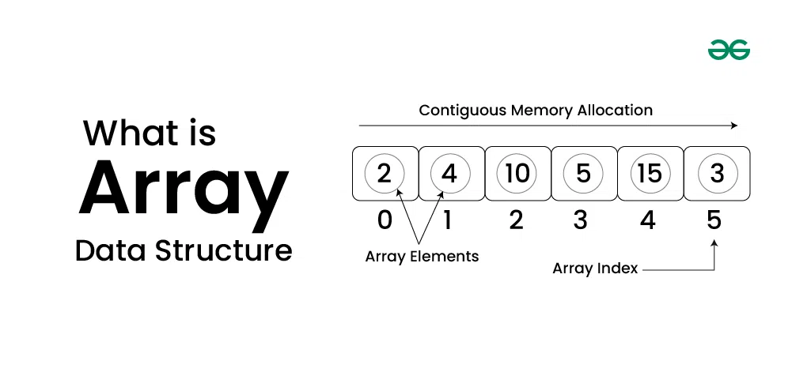
Linear Data Structures are a type of data structure in computer science where data elements are arranged sequentially or linearly. Each element has a previous and next adjacent, except for the first and last elements.“Location of next index depends on the data type we use”.

Is the array always of a fixed size?
Arrays at core are of fixed size only, but most of the languages provide dynamic sized arrays using the underlying fixed sized arrays. For example, vector in C++, Array List in Java and list in Python. In C language, the array has a fixed size meaning once the size is given to it, it cannot be changed i.e. you can’t shrink it nor can you expand it.
The idea of an array is to represent many instances in one variable.

Basic terminologies of Array

- Array Index: In an array, elements are identified by their indexes. Array index starts from 0.
- Array element: Elements are items stored in an array and can be accessed by their index.
- Array Length: The length of an array is determined by the number of elements it can contain.

Declaration of Array & Initialization of Array in python

Need or Applications of Array Data Structures

- Array is a fundamental data structure and many other data structure are implemented using this. Implementing data structures such as stacks and queues
- Representing data in tables and matrices
- Creating dynamic data structures such as Hash Tables and Graph.
- When compared to other data structures, arrays have the advantages like random access (we can quickly access i-th item) and cache friendliness (all items are stored at contiguous location)

TYPES OF ARRAY
Arrays can be classified in two ways:
- On the basis of Size
- On the basis of Dimensions
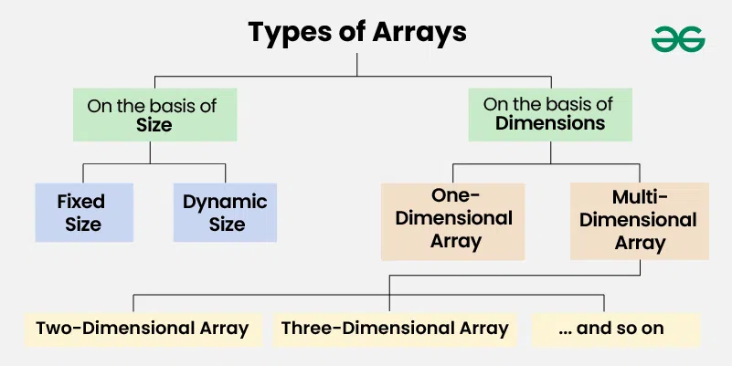

. Fixed Sized Arrays:
We cannot alter or update the size of this array. Here only a fixed size (i,e. the size that is mentioned in square brackets []) of memory will be allocated for storage. In case, we don’t know the size of the array then if we declare a larger size and store a lesser number of elements will result in a wastage of memory or we declare a lesser size than the number of elements then we won’t get enough memory to store all the elements. In such cases, static memory allocation is not preferred.

# Create a fixed-size list of length 5,
# initialized with zeros
arr = [0] * 5

# Output the fixed-size list
print(arr)

2. Dynamic Sized Arrays:
The size of the array changes as per user requirements during execution of code so the coders do not have to worry about sizes. They can add and removed the elements as per the need. The memory is mostly dynamically allocated and de-allocated in these arrays.

# Dynamic Array
arr = []

TYPES OF DIMENSIONS ARRAY

1. One-dimensional Array(1-D Array): You can imagine a 1d array as a row, where elements are stored one after another

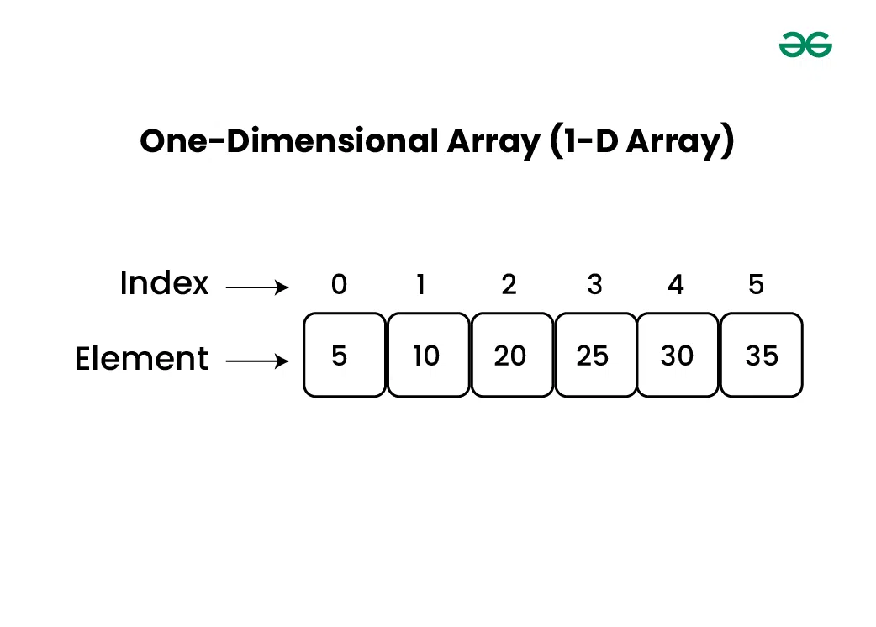
2.Multi-dimensional Array: A multi-dimensional array is an array with more than one dimension. We can use multidimensional array to store complex data in form of tables etc. We can have 2-D array ,3-D arrays,4-D arrays and so on

OPERATION ON ARRAY:

1.Array traversal : Array traversal involves visiting all the elements of the array once.

2.Insertion in Array : We can insert one or multiple elements at any position in the array.

3.Deletion in Array : We can delete an element at any index in an array.

4. Searching in Array : We can traverse over an array and search for an element.

